The successful completion of any project is an end result of the successful and coherent combination of ideas and efforts of the involved members. The same is true for this project. The reason for the successful completion of this project is unquestionably help and support achieved from my faculties and friends who guided me, advised me and finally made me capable to transform the ideas into successful work.

I am very grateful to Miss.Priyanka Dabasara. Who helped us in the successful completion of this project.

I am highly thankfull to them who sincerely provided me the necessary information and valuable suggestions and time for completing this project in the best possible way I also thank all my friends and family for being a wonderful support.

“Changes are the only constant thing in the world”

To compete in today’s competitive market the strategies you Design and use should resolve around the current market.

We can also say, “Experience is the best teacher” So our project is one kind of Experience, the part of our life. Through the project we have learnt Good, Real and Practical application.

Computers have made their way in every aspect of our life. With this initiation of computers on human life style to survive in the market a need to develop more users friendly software’s arise, it is the survival of the fittest.

Mr.Hit Soliya. and Mr. Maulik khunt. and Mr.Rameshvar Gondaliya . Students of BCA. (SEM-V) Here, based on our study, we declare that all the information and facts presented in this report are original in nature.

We signature holders declare that the project “Online Hotel Booking For Royal Hotel” made by us. This project has been made under the guidance of Miss.Priyanka Dabasara.This is our original work and we have collected the information according to their experience. The matter shown in this project is not a copy of anybody. We also understand the copy matter is not confidential and also it is one type of crime against University.

Soliya Hit

Khunt Maulik

Gondaliya Rameshvar

“ONLINE HOTEL BOOKING FOR
ROYAL HOTEL”

- Information means take reference to prepare any project. Here I Concern the book and website, guide and old project which takes reference in order.

- By The Reference of Demonstration Project, Collect the Information from Main Branch....! Royal hotel, Ahemdabad and more information are collecting ,Sharkhej Roza Road.

- Opp Janera l Medical Store,Ahemdabad, Phone:(00)22264453 , Fax:(000)123 321 123 0 , Email: royal_hotel@.gmail.com

Website :
- www.royalhotel.com

Study of Existing System

- Some modules of existing system is manually like that when we create new customers that entry will be directly enter to the database.

- In existing system the domain hours is counting on the weekly report. But how much work done user that will not measured.

Need for the New System

- Existing system is providing the less security so user can login anywhere.

- User and customer information directly maintain by database not any GUI interface available for putting information.

- Data Normalization is not properly in old system.

Objective of the Project

- New system is providing attractive GUI Environment.

- New system is providing the high security like IP authorization putting from user login.

- It can easily use to any user.

- Data can manage properly.

Limitation of System

- Unnecessary duplication of data.
- Retrieval of guest records is extremely
Difficult.
- Data entry procedure is prone to errors.

Tool Used:

1. Front End Tool: PHP
2. Back End Tool: MYSQL
3. Server: WAMP Server
4. Operating System: Windows 7/10
5. Documentation Tools: Microsoft Word 2007

Hardware Specification:

- Processor: Intel core i5/i7
- Cache Memory: 512 KB
- Random Access Memory: 4 GB
- Hard Disk Drive: 1 TB
- Monitor: Laptop / PC
- Keyboard: Keyboard
- Mouse: Mouse

Software Specification:

OPERATING SYSTEM: Windows 7/10
MICROSOFT WINDOW PLATFORM

Front End Tool:PHP

The full form of PHP is “Hype-Text Pre Processor” or “Personal Home Page”.

- Resumes Leadoff software engineer, Apache team member is the creator and original driving force behind PHP. The first part of PHP was developed for his personal use in late 1994.

- PHP is one of the most widely spread server-side scripting languages.

- PHP is server-side scripting language, which can be embedded in HTML or used as a stand-alone.

- Someone looking at a PHP page will not necessarily be able to tell it was not written purely in HTML, because usually the result of PHP is HTML.

- PHP is an official module of Apache HTTP server.

- There are many reasons why PHP is so popular – it is fast, has thorough documentation, is supported by a large enthusiastic community and last but not least it has free and open source libraries.

Advantages of PHP

- Cost :

- PHP costs you nothing. It is open source software and doesn’t need to purchase it for development.

- Ease Of Use :

- PHP is easy to learn, compared to the others. A lot of Ready-made PHP scripts are freely available in market so, you can use them in your project or get some help from them.

- HTML – Support :

- PHP is embedded within HTML; In other words, PHP pages are ordinary HTML pages that escape into PHP mode only when a client requests this page, the web server preprocesses it. This means it goes thought the page from top to bottom, looking for sections of PHP, which it will try to resolve.

- Cross-platform compatibility :

- MySQL run native on every popular flavor of UNIX and windows. A huge percentage PHP and of the world’s HTTP servers run on one of these two classes of operating system.

- PHP is compatible with the three leading Web servers :

- Apache HTTP server for UNIX and windows, Microsoft internet information server, and Netscape Enterprise server. It also works with several lesser-known servers, including Alex Bits’ fatted, Microsoft’s personal Web
server, AOL server and Omnicentrix’s Omni server application server.

- Stability

- The word stable means two different things in this context.
- The server doesn’t need to be rebooted often.
- The software doesn’t change radically and incompatibly from release to release.

- Speed :

- PHP is pleasingly zippy in its execution, especially when compiled as an Apache module on the UNIX side although it takes a slight performance hit by being interpreted rather than compiled; this is far outweighed by the benefits PHP drives from its status as a Web server module.

CSS

- CSS is an acronym for Cascading Style Sheets.

- CSS is a style language that defines layout of HTML documents.

- The benefits of CSS are control layout of many documents from one single style sheet, More precise control of layout. Apply different layout to different layout to different media-type(screen,print,etc.).

Advantages of CSS

- CSS save time :

- With CSS, you only have to specify these details once for any element. CSS will automatically apply the specified style whenever that element occurs.

- Pages load faster:

Less code means faster download times.

- Easy maintenance:

To change the style of an element, you only have to make an edit in one place.

- Superior Style to html:

CSS has a much wider array of attributes than HTML.

Back End Tool:-MYSQL

  - MySQL, the most popular open source SQL database management system, is developed, distributed, and supported by MySQL.

  - A Back-End Database is a database that is accessed by users indirectly through an external application rather than by application programming stored within the database itself or by low level manipulation of the data.

  - The MySQL web site (http://www.mysql.com/) provides the latest information about MySQL software and MySQL.

  - A back-end database stores data but does not include end-user application elements such as stored queries, forms, macros or reports.

  - The MYSQLdump client utility performs logical backups, producing a set of SQL statements that can be executed to reproduce the original database object definitions and table data. It dumps one or more MySQL databases for backup or transfer to another SQL server.

MY SQL Features

- MySQL is a relational database management system.

  - MySQL software is open source.

  - The MySQL database server is very fast, reliable, and easy to use.

  - MySQL server works in client/server or embedded systems.

  - A large amount of contributed MySQL software is available.

  - Because of its unique storage engine architecture MySQL performance is very high.

  - Supports large number of embedded applications which makes MySQL very flexible.

  - Use of Triggers, Stored procedures and views which allows the developer to give a higher productivity.

  - Allows transactions to be rolled back, commit and crash recovery.

Project Title | “ONLINE HOTEL BOOKING SYSTEM FOR ROYAL HOTEL”
Project Definition | A Royal Hotel is a dessert that conisit of large rooms . Which is baked similarly to a batch of regular sized clean a rooms and usually decorated with forsting.
Developed by | - Soliya Hit  - Khunt Maulik  - Gondaliya Rameshwar
Objective | Online Booking For Royal Hotel
Compatible Platform | Microsoft Window 7/10
Front End Tool | PHP
Back End Tool | MY SQL
Documentation Tool | Microsoft Word 2007
Modules | User Side and Admin Side
Project Team Size | Three
Guide by | Miss.Priyanka Dabasara.

Display all PHP Errors and Warnings

Everyone makes mistakes when writing PHP code no matter your experience level. There are many common mistakes that sometimes are not immediately clear when looking at the error that PHP displays. First and foremost, when debugging PHP code, make sure you include the proper code to Display PHP Errors.
Parse error: syntax error, unexpected ‘}’

When forget an opening curly brace ‘{‘, or if an extra closing curly brace, this error is generated at the closing brace. Many frameworks and syntax highlighters such as Notepad++ will assist in finding the matching brace by simply placing cursor next to a curly brace.

How to solve it:
Solving above error is ending of the ‘}’ brace. this type of error is solving is easy to handle.

- Type mismatch Error :-

"Data Type Mismatch" error in which “Username” field have number type is assigned, it will be use only “Text” data type.

How to solve it:
Solving above error is assigned valid data type of the field.

- In Valid Variable Number :-

How to solve it:
In php , Other programming languages variables can’t start with number .
- Missing ‘$’ :-
How to solve it:
Add ‘$’ sign before php variable.

Software Testing Errors/ Issue

The phase of system development life cycle tests system design. Testing of system decides whether the newly designed system works properly or not. After the development of documentation manually about the system this stage is checked.

if the system working properly then it will be considered for implementation and if It isn’t then it will be considered for implementation and if isn’t then system analyst is informed to find out generated errors or problems and to find out its solutions. This process is known as debugging.

For any software system testing means to check out it’s coding. If there is not any problem in the coding then that code is proper and efficient to design. If we are not getting proper or required output then we have to debug the system coding. So, the debugging is also a subpart of the testing section. If the system runs correctly during testing then there is no need to debug.

During the testing of our project we have to face different types of errors. Especially, database errors annoyed us but at last we solved

it, successfully. Some of the errors are listed below with their cause and solution.

if the system working properly then it will be considered for implementation and if It isn’t then it will be considered for implementation and if isn’t then system analyst is informed to find out generated errors or problems and to find out its solutions. This process is known as debugging.

For any software system testing means to check out it’s coding. If there is not any problem in the coding then that code is proper and efficient to design. If we are not getting proper or required output then we have to debug the system coding. So, the debugging is also a subpart of the testing section. If the system runs correctly during testing then there is no need to debug.

During the testing of our project we have to face different types of errors. Especially, database errors annoyed us but at last we solved it, successfully. Some of the errors are listed below with their cause and solution.

Client Side

Single AC

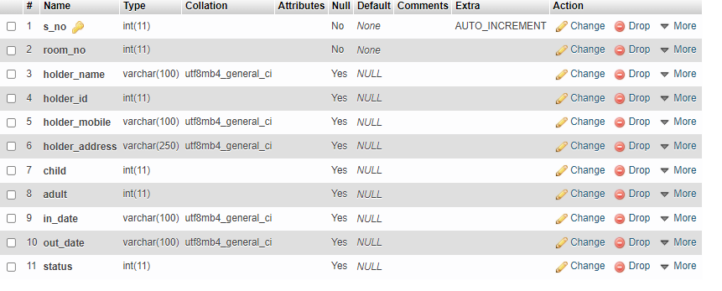

Signal Non AC

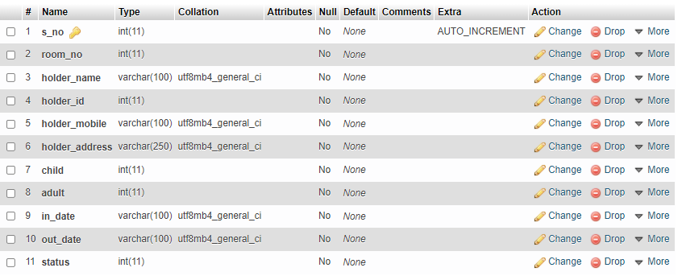

Double AC

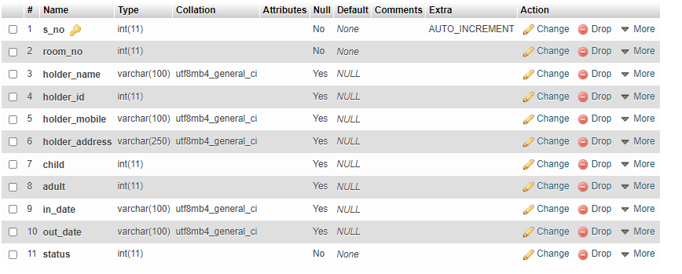

Double Non AC

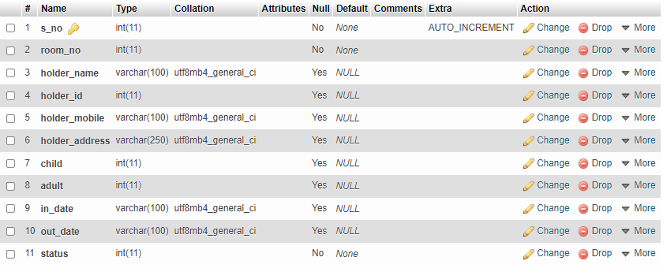

Payment

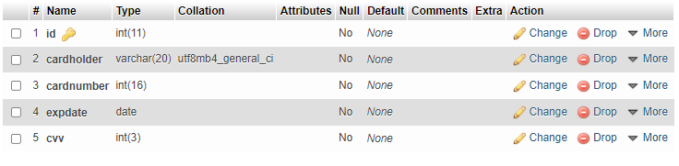

Admin Side:

Admin Login

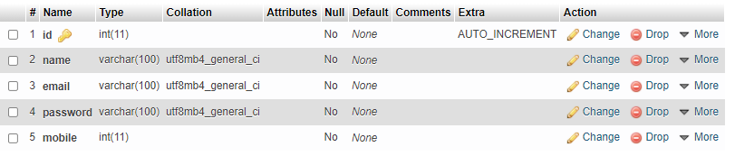

User side:

Home Page

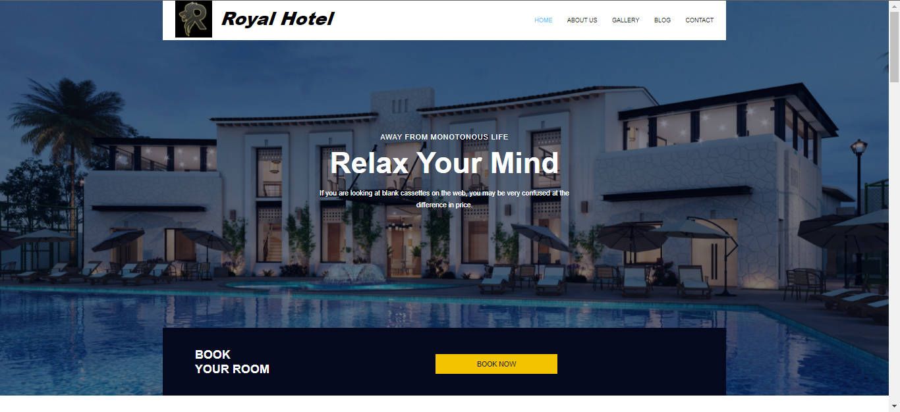

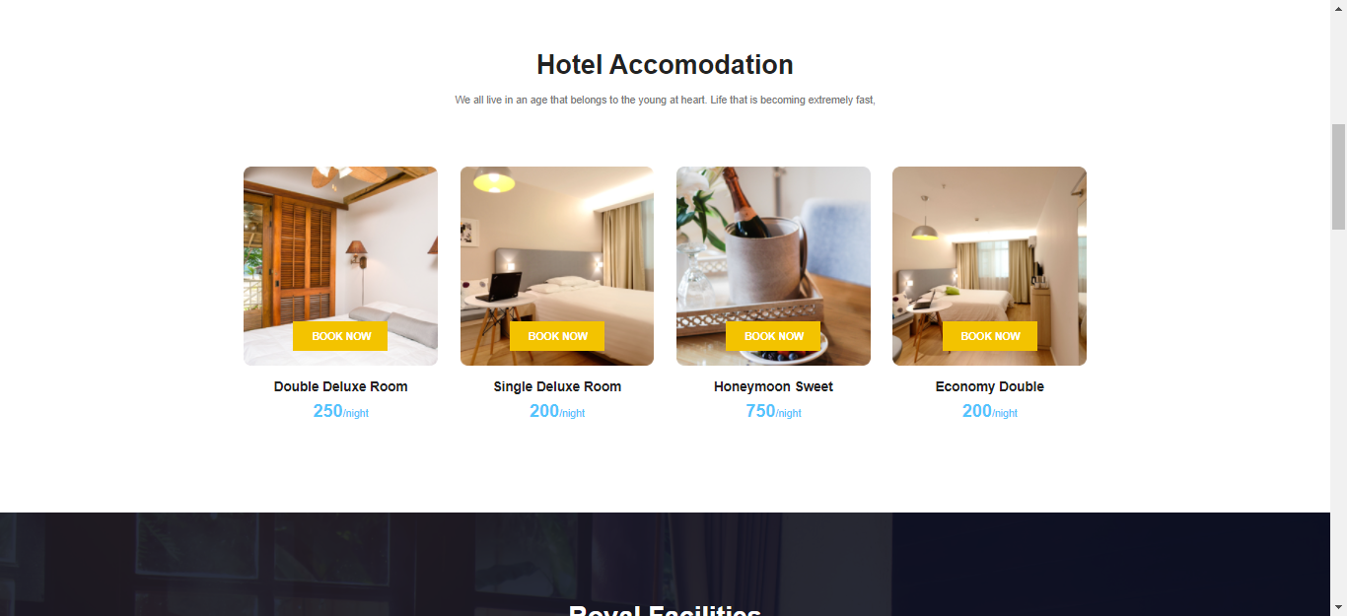

About US

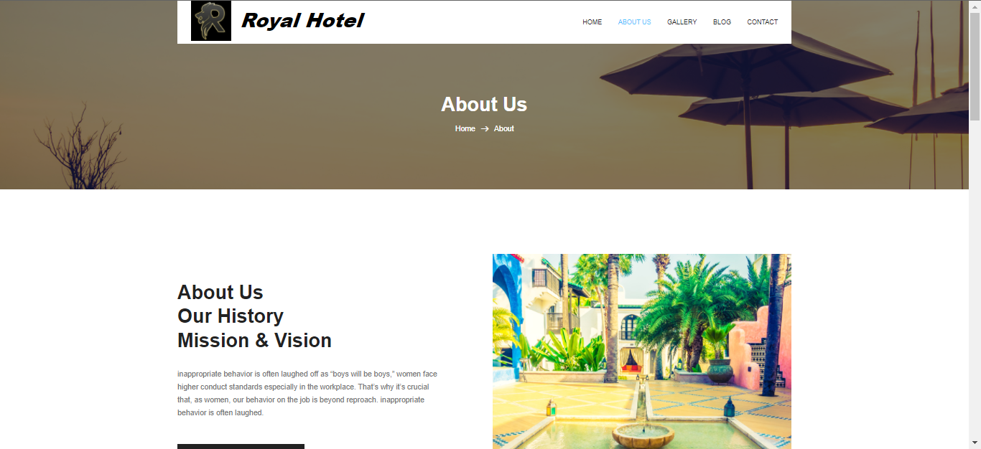

Gallery

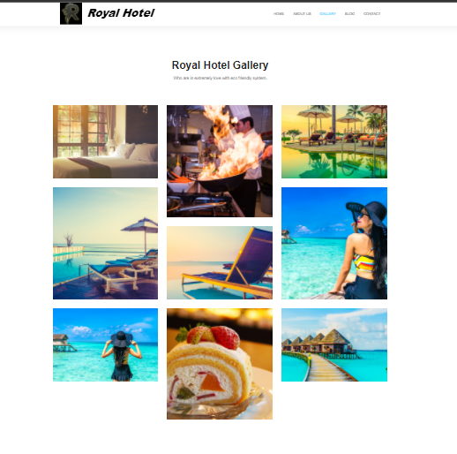

Blogs

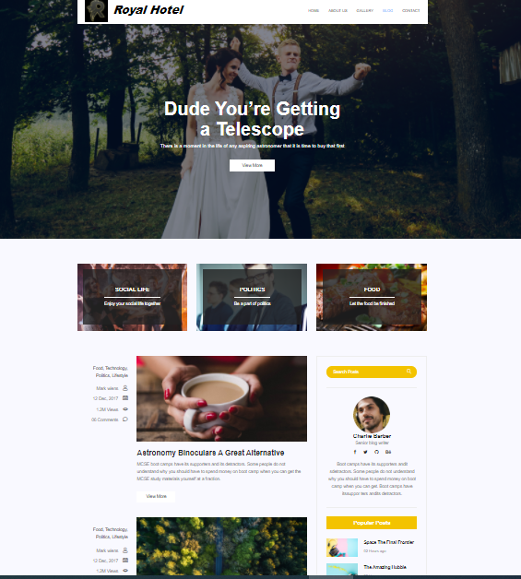

Blog ditels

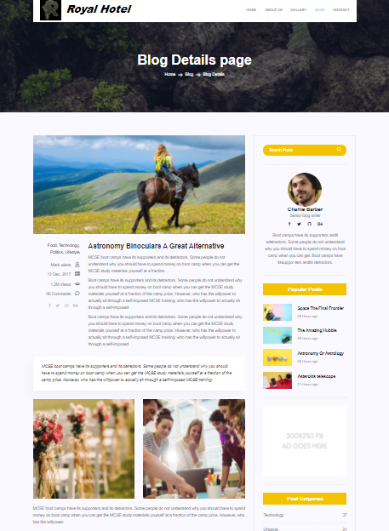

Contect

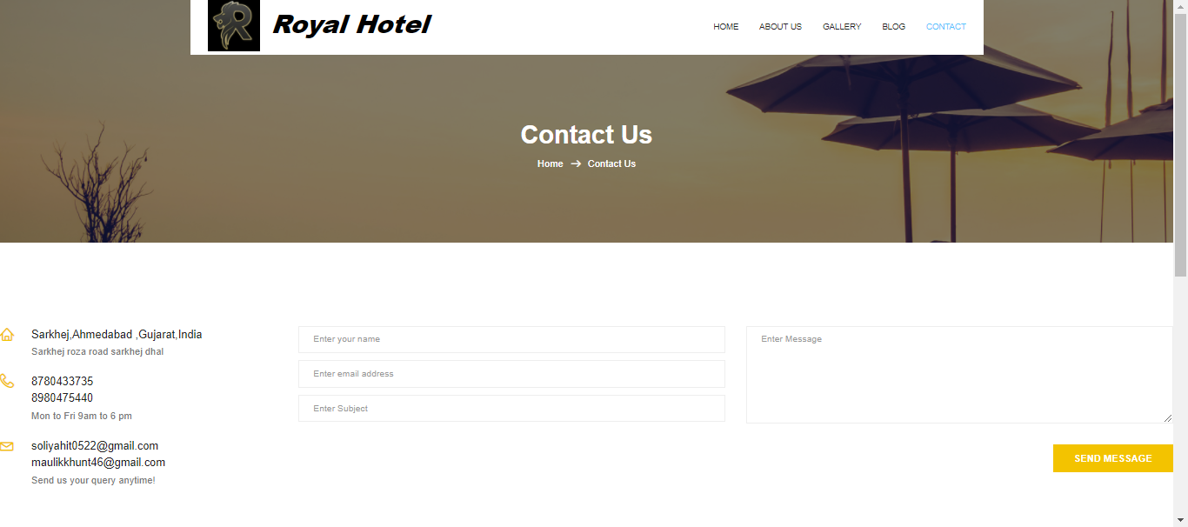

Rooms

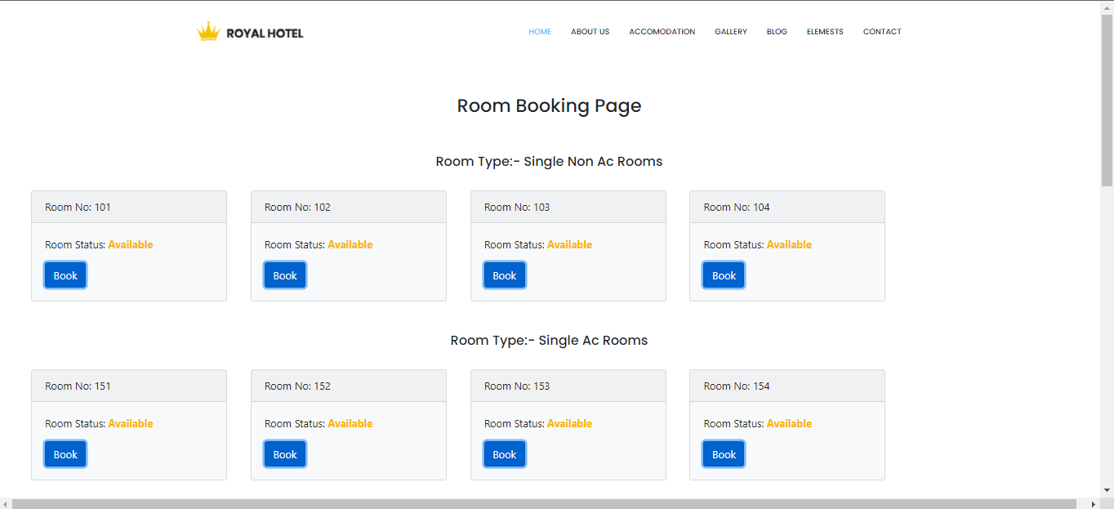
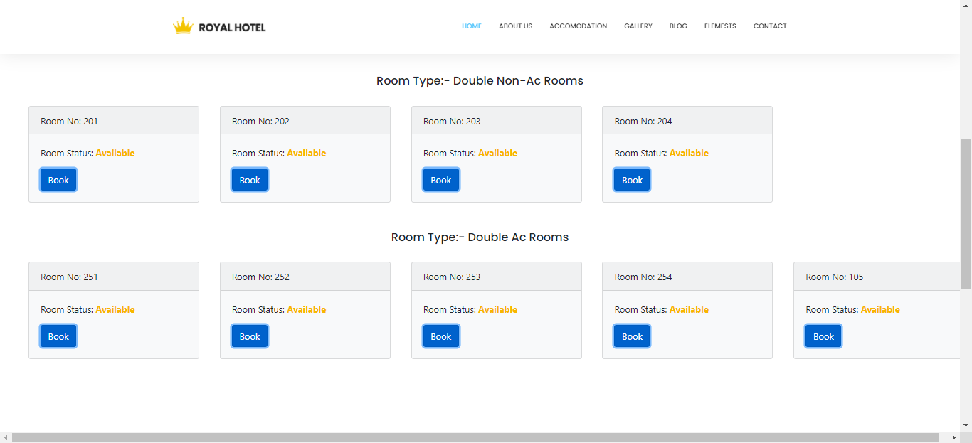
U

Room Booking Page

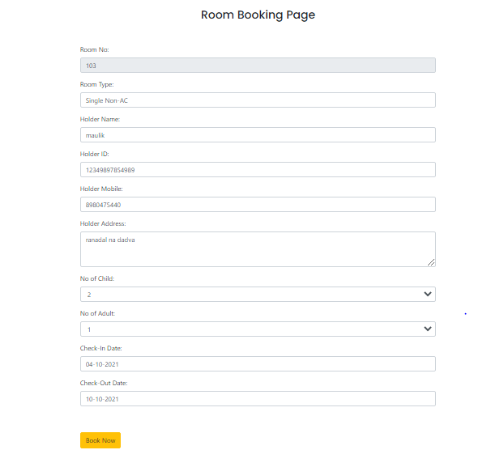

Booked Room
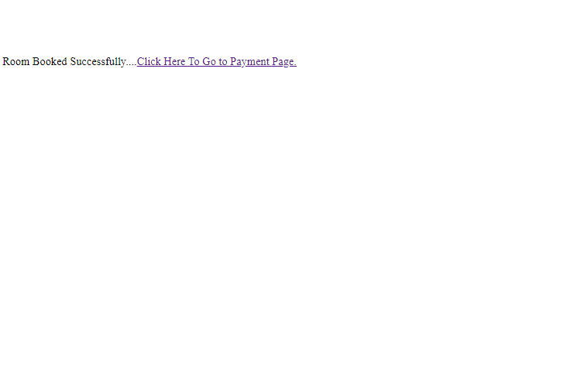

Payment Page

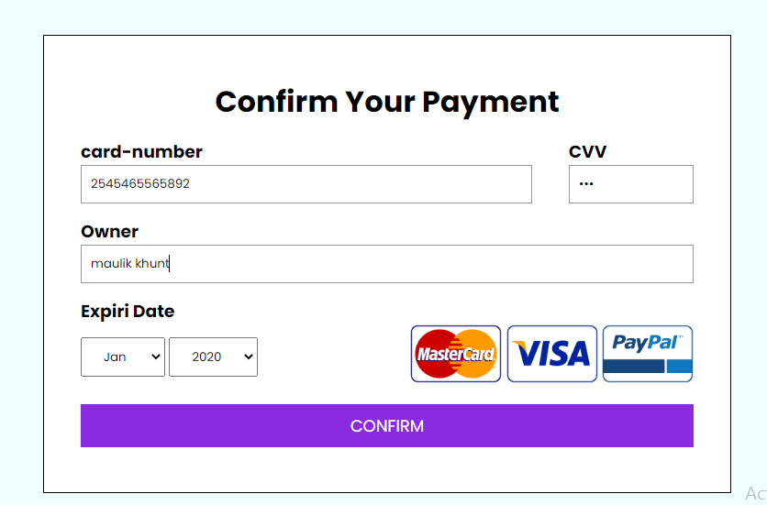

Admin Side:

Admin Login page

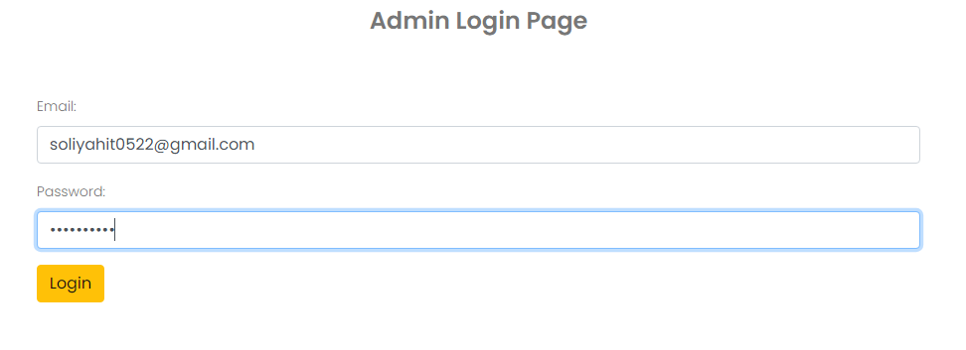

Admin dashboard Page

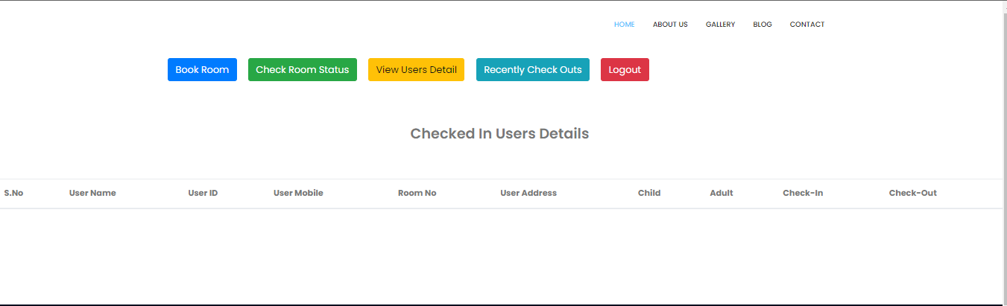

Rooms P

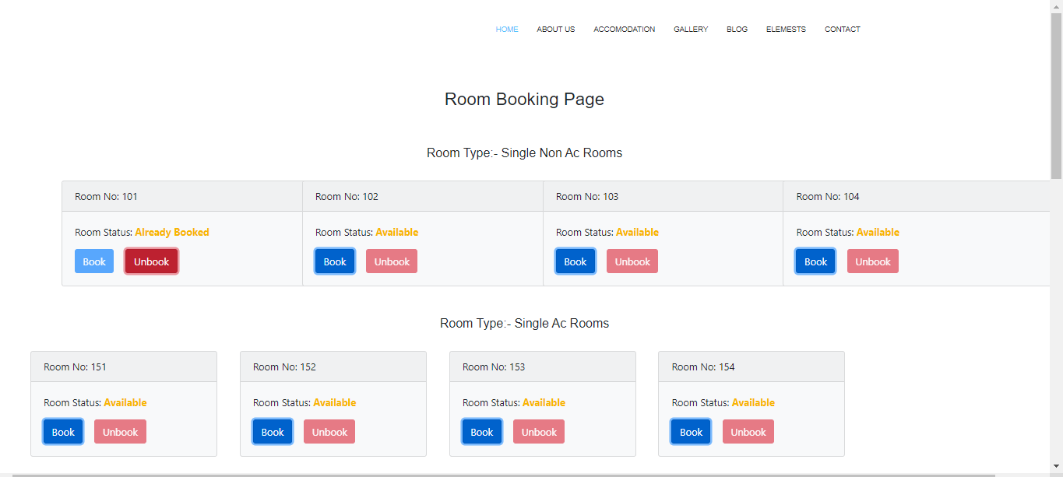

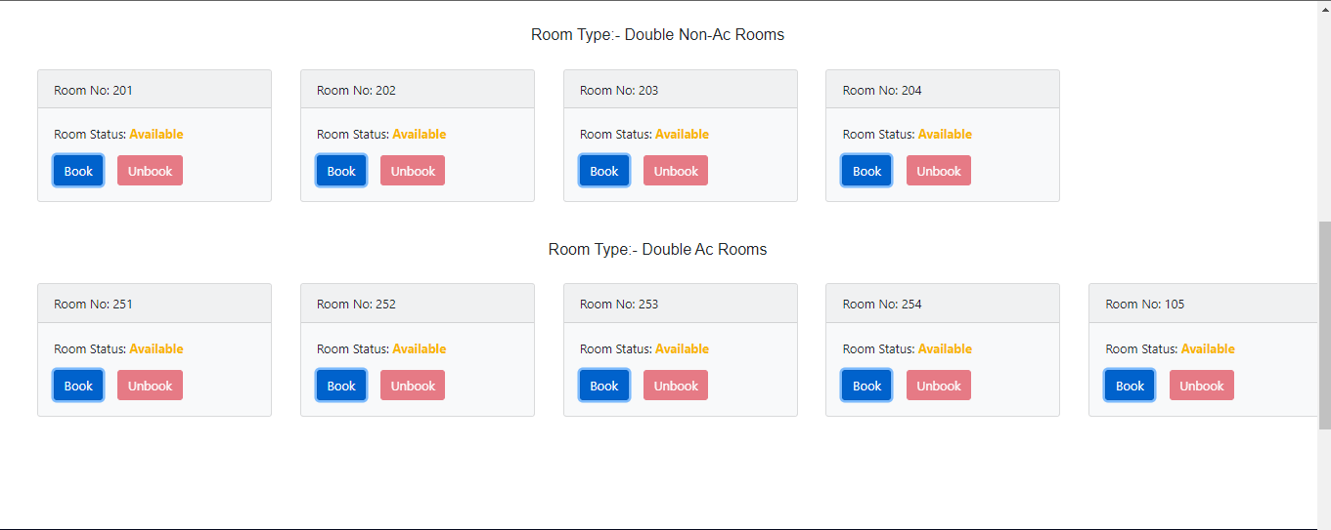

Room status

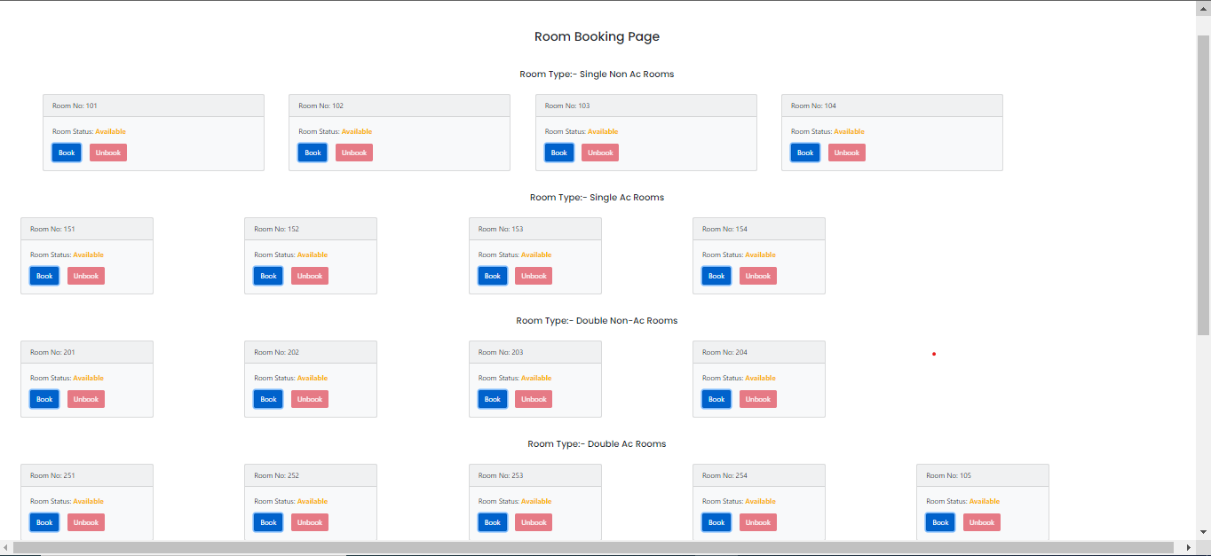

Book Room Page

Book Room

Unbook Room Page

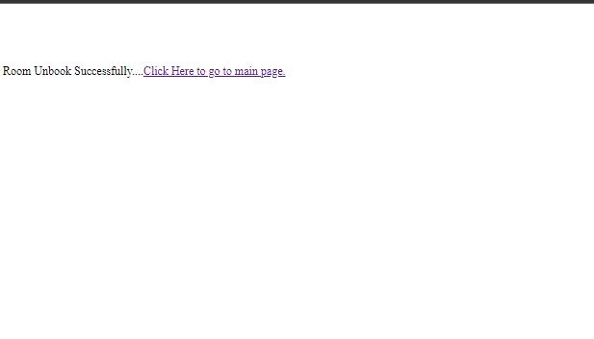

Advantages :

- To book any room the payment Credit Card/Debit Card are available.

- The Royal Hotel provide in many category wise rooms such as
Singl Ac, Single non Ac, Double Ac, Double non Ac.

- You can book any room from home page.

- No third-party commission fee.

- Save your time & money.

- Hotel business open 24/7.

Disadvantages :

- Our hotel is limited rooms.

- The cash payment not allows only Debit Card/Credit Card is available.

- You need internet access.

